Meeting Notice
Subject: Review of Academics, Placements, and Industry Collaborations.

All HODs, In-Charge HODs, and Training & Placement Officer are hereby informed that a meeting is scheduled for tomorrow,19-06-2025, at 12:00 PM in the office of the Principal, Kashmir Government Polytechnic College, Srinagar.

The agenda for this meeting will broadly cover:
Academics and TPO-Related Matters
Industry MOUs & Trainings
Overall Review of Academics and Placements

No: KGP/Estt/2025/396
Dated:18-06-2025
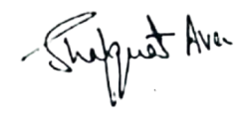

Dr. Shafquat Ara
Principal
Kashmir Govt.Polytechnic College Srinagar

